# Module 2 - Assignment 2

## Pierce, Michaela

### Introduction to R Markdown

This is my first R Markdown document. It will go over some previous topics covered in class such as atomic vectors, data frames, and data types.

The code I will be entering will contain a basic plot showing sales over the past 6 months.

library(tidyverse)

## ── Attaching core tidyverse packages ──────────────────────── tidyverse 2.0.0 ──  
## ✔ dplyr 1.1.4 ✔ readr 2.1.5  
## ✔ forcats 1.0.0 ✔ stringr 1.5.1  
## ✔ ggplot2 3.5.0 ✔ tibble 3.2.1  
## ✔ lubridate 1.9.3 ✔ tidyr 1.3.1  
## ✔ purrr 1.0.2   
## ── Conflicts ────────────────────────────────────────── tidyverse_conflicts() ──  
## ✖ dplyr::filter() masks stats::filter()  
## ✖ dplyr::lag() masks stats::lag()  
## ℹ Use the conflicted package (<http://conflicted.r-lib.org/>) to force all conflicts to become errors

sales <- c(50, 150, 200, 100, 300, 250)   
month <- c(1, 2, 3, 4, 5, 6)  
qplot(month, sales, geom = "point", xlab = "Month", ylab= "Sales")

## Warning: `qplot()` was deprecated in ggplot2 3.4.0.  
## This warning is displayed once every 8 hours.  
## Call `lifecycle::last_lifecycle_warnings()` to see where this warning was  
## generated.

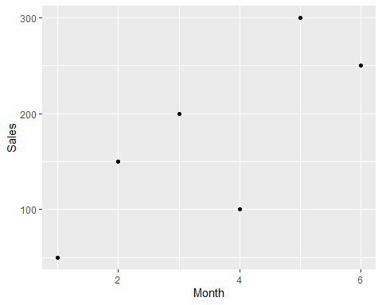

What month had the largest sales? Month 5

What was the amount? 300

month <- c("Jan", "Feb", "Mar", "Apr", "May", "Jun", "Jul", "Aug", "Sep", "Oct", "Nov", "Dec")  
sales <- c(150.25, 258.54, 268.55, 122.52, 987, 458.82, 667.23, 845.54, 586.78, 888.58, 756.12, 456.84)  
Yearly_sales <- data.frame(month, sales)  
   
library(ggplot2)  
qplot(data = Yearly_sales, y = Yearly_sales$month, x = Yearly_sales$sales,main = "Monthly Sales", xlab = "Sales",ylab = "Month")

## Warning: Use of `Yearly_sales$sales` is discouraged.  
## ℹ Use `sales` instead.

## Warning: Use of `Yearly_sales$month` is discouraged.  
## ℹ Use `month` instead.

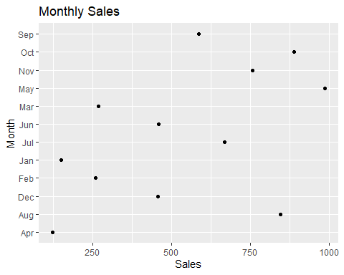

Which month had the most sales? May = 987  
Which month had the least sales? Apr = 122.52